#########################Date 23rd March 2019 ##############################

1. 5 / 2 will give result as 2.5 in python but if we want result in integer then we have write like 5 //2 . In that case, we will get result as 2
2. If we want to print Deepak 4 times then we have write like 4 * Deepak
3. \n is getting used for new line so use ‘r’ in the beginning to avoid getting new line . example

Print(r’C:\deepak\notes’)

1. If you want to add double code also in the printed line then

Print(‘deepak “Kumar”’)

1. _ is used to get previous result
2. Len method is used to get the number of characters in the string. Example : name = ‘deepak’

Now the output of len(name) will be 6.

1. ## once you create the object, we can't change the content is called immutable (Non changeable).
2. List object is **mutable** ( as we can insert and delete) and tuple is **immutable** ( we can’t insert or delete) . List is represented with [] where as tuple is represented as ()
3. [] -🡪 list, ()🡪tuple and {} 🡪 Set, {} -🡪 dict
4. There is no char data type in python.
5. Long data type was available in python 2 but long data type is not available in python 3
6. There are 5 fundamental data type in Pthon ( int,float, complex,bool,str)
7. print(type(input("enter the value"))) # type of input is str by default.
8. Exit() keyword is used to come out from
9. # return type of **Input function** is always string only.
10. By default value of sep is space. Print(10,20,30,sep=’ ‘)
11. By default value of end is new line (\n).
12. X++ or x—are not available in Python.
13. Did not watch video from 20
14. In python, there is no char data type
15. Del keyword delete the object
16. None keyword set the value as None.
17. Use ‘’’ if you want to print both ‘ and “ code available in the string
18. We can use -Ve index also to access string character. It will give value from right to left
19. Strip method available for string is used to remove the spaces.
20. Functions which are declare outside the class : functions
21. Function which are declare inside the class : methods
22. Use this code to define empty set i.e s1 = set()
23. Code for even and odd number ::

LL3={1,2,3,4,5,6,8,9,10}

LL4 = [ i for i in LL3 if i%2 == 0]

LL5= [ i for i in LL3 if i%2 !=0]

print(*"List of sum numbers :: "*,LL4)

print(*"List of odd number :: "*,LL5)

1. Functions : group of statements
2. Module : Group of functions
3. Package : Group of modules
4. Library : Group of package.

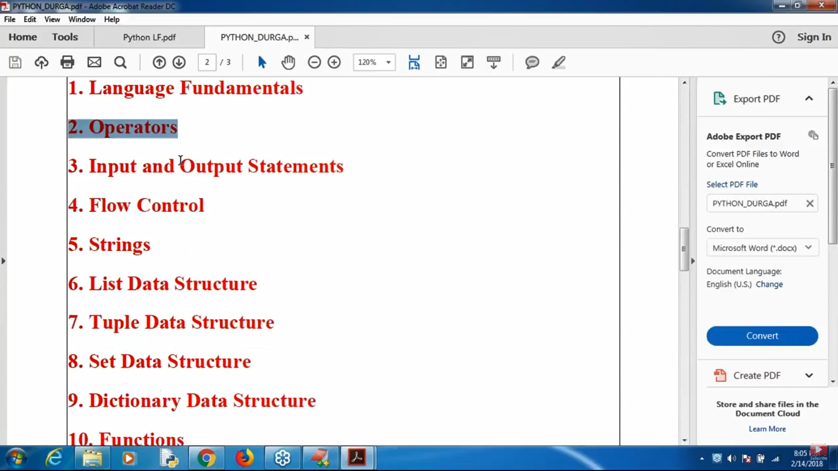

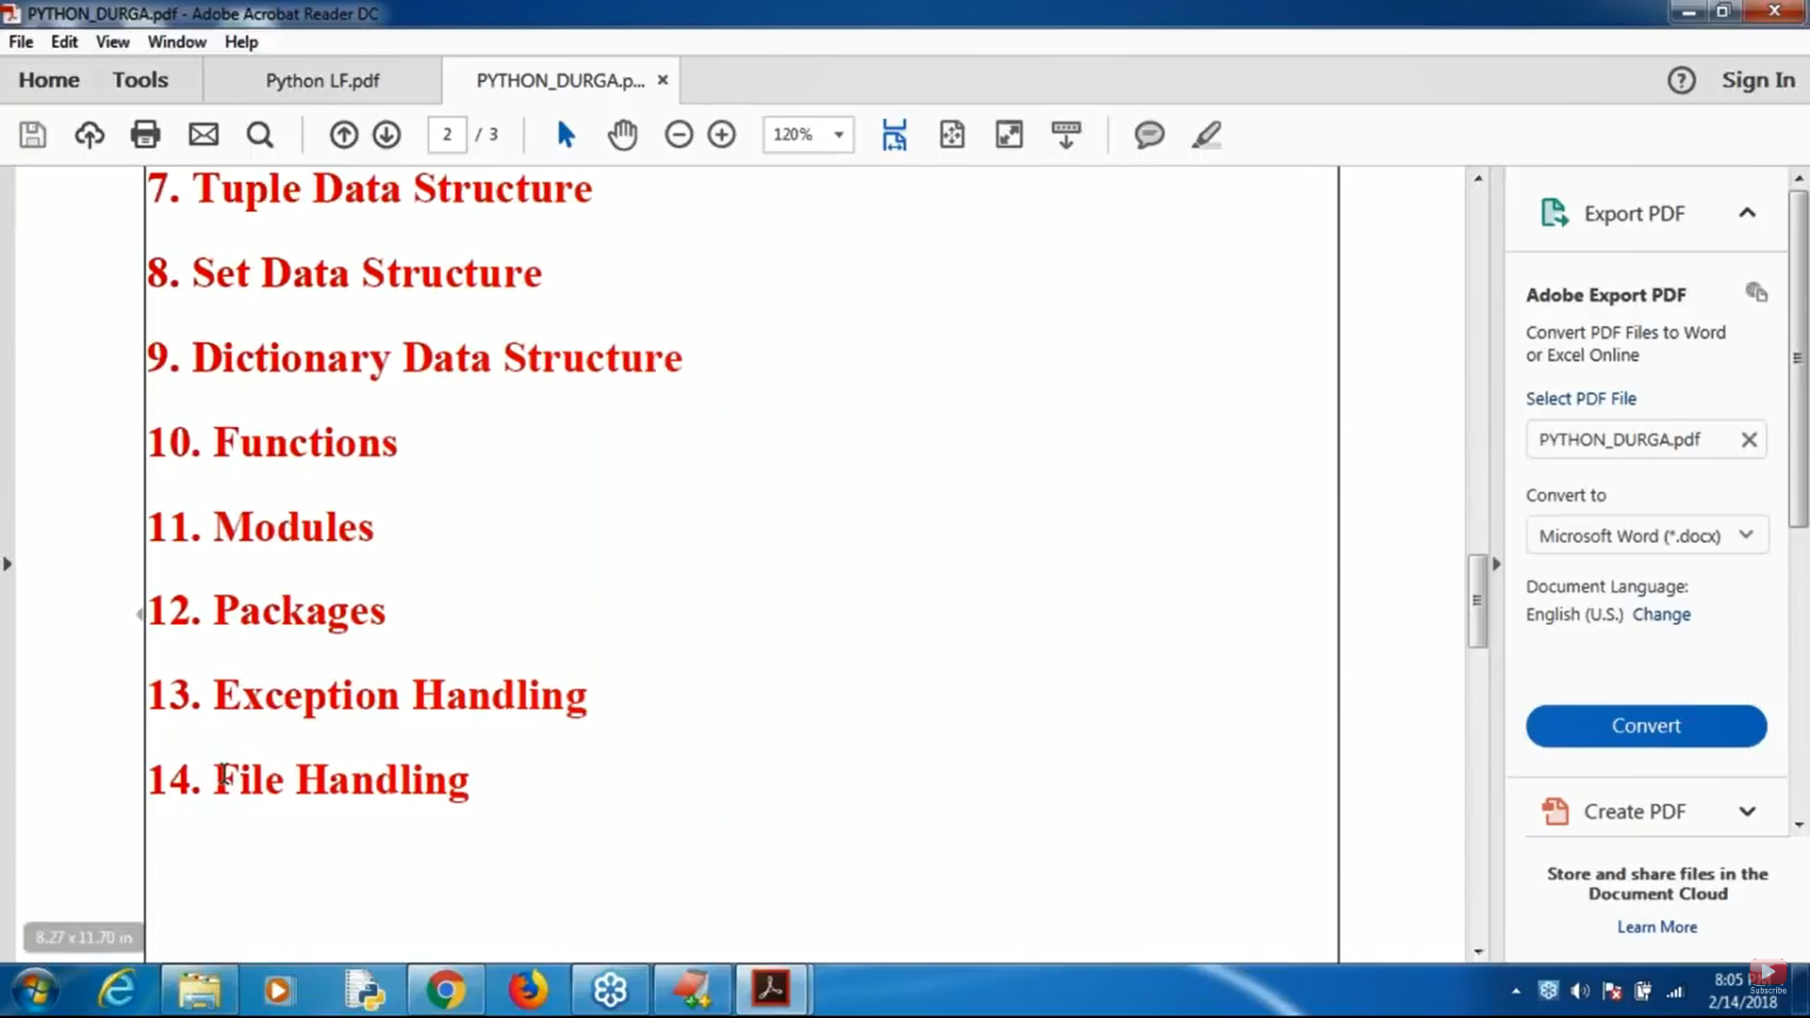

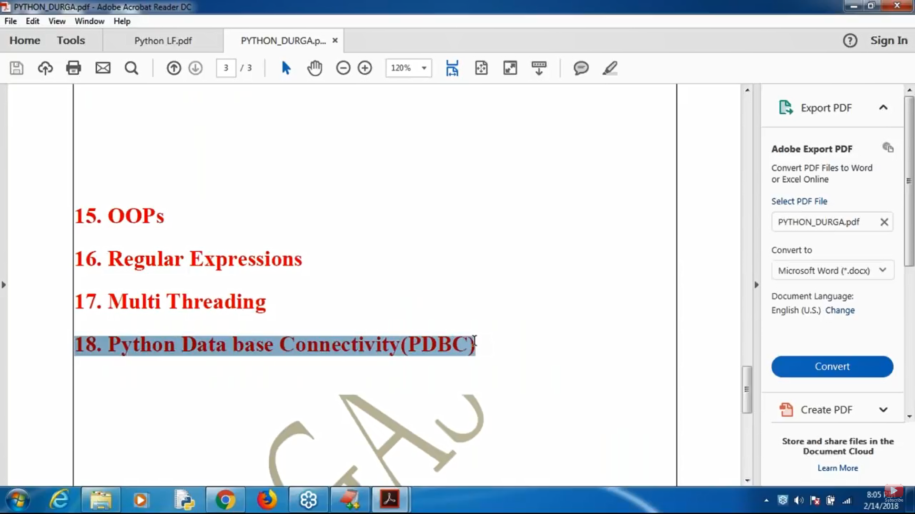

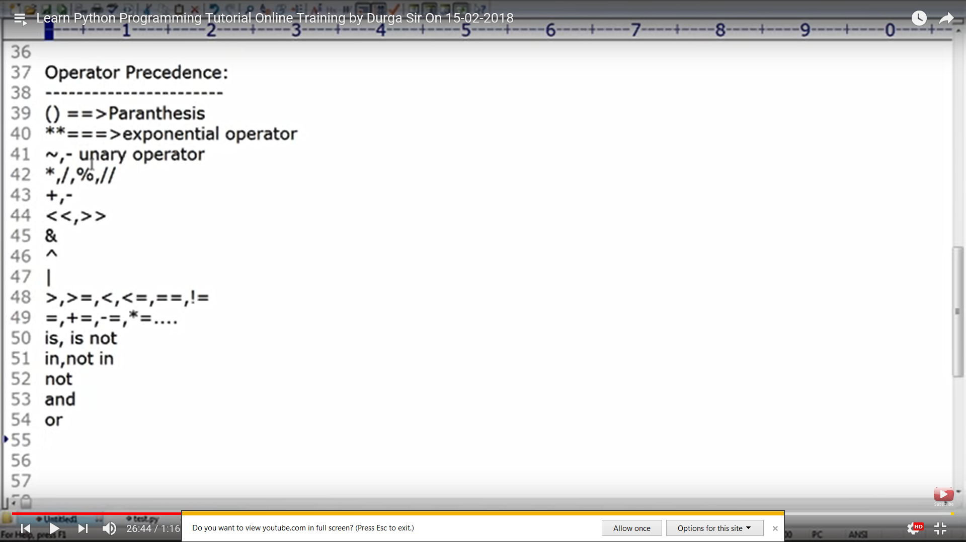

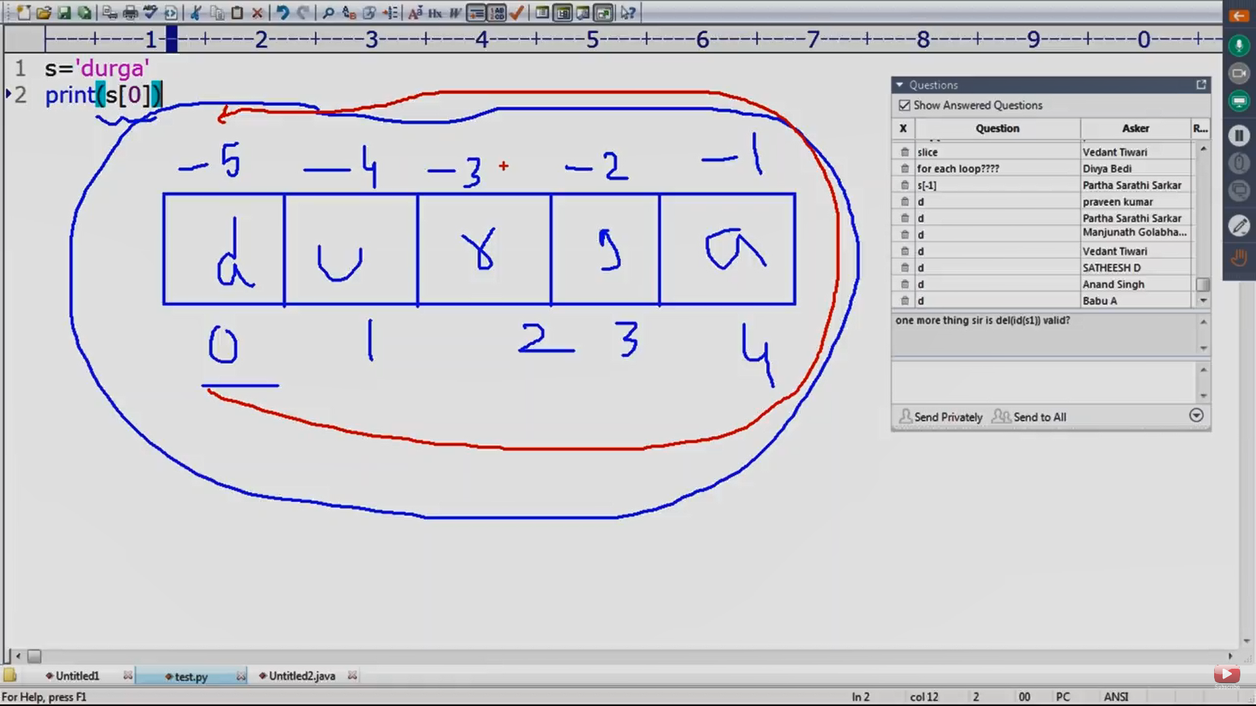

Slice Concept ::

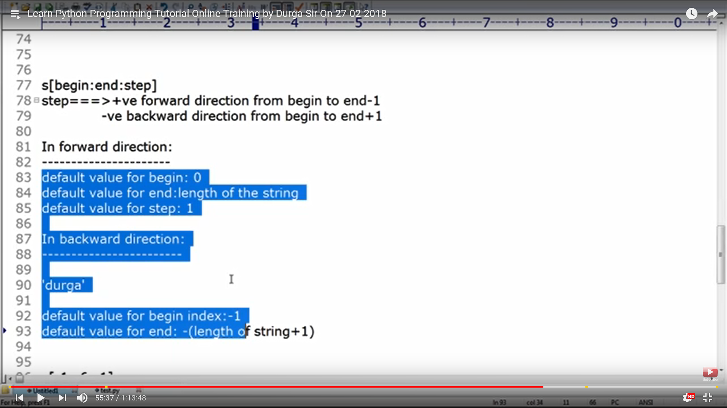

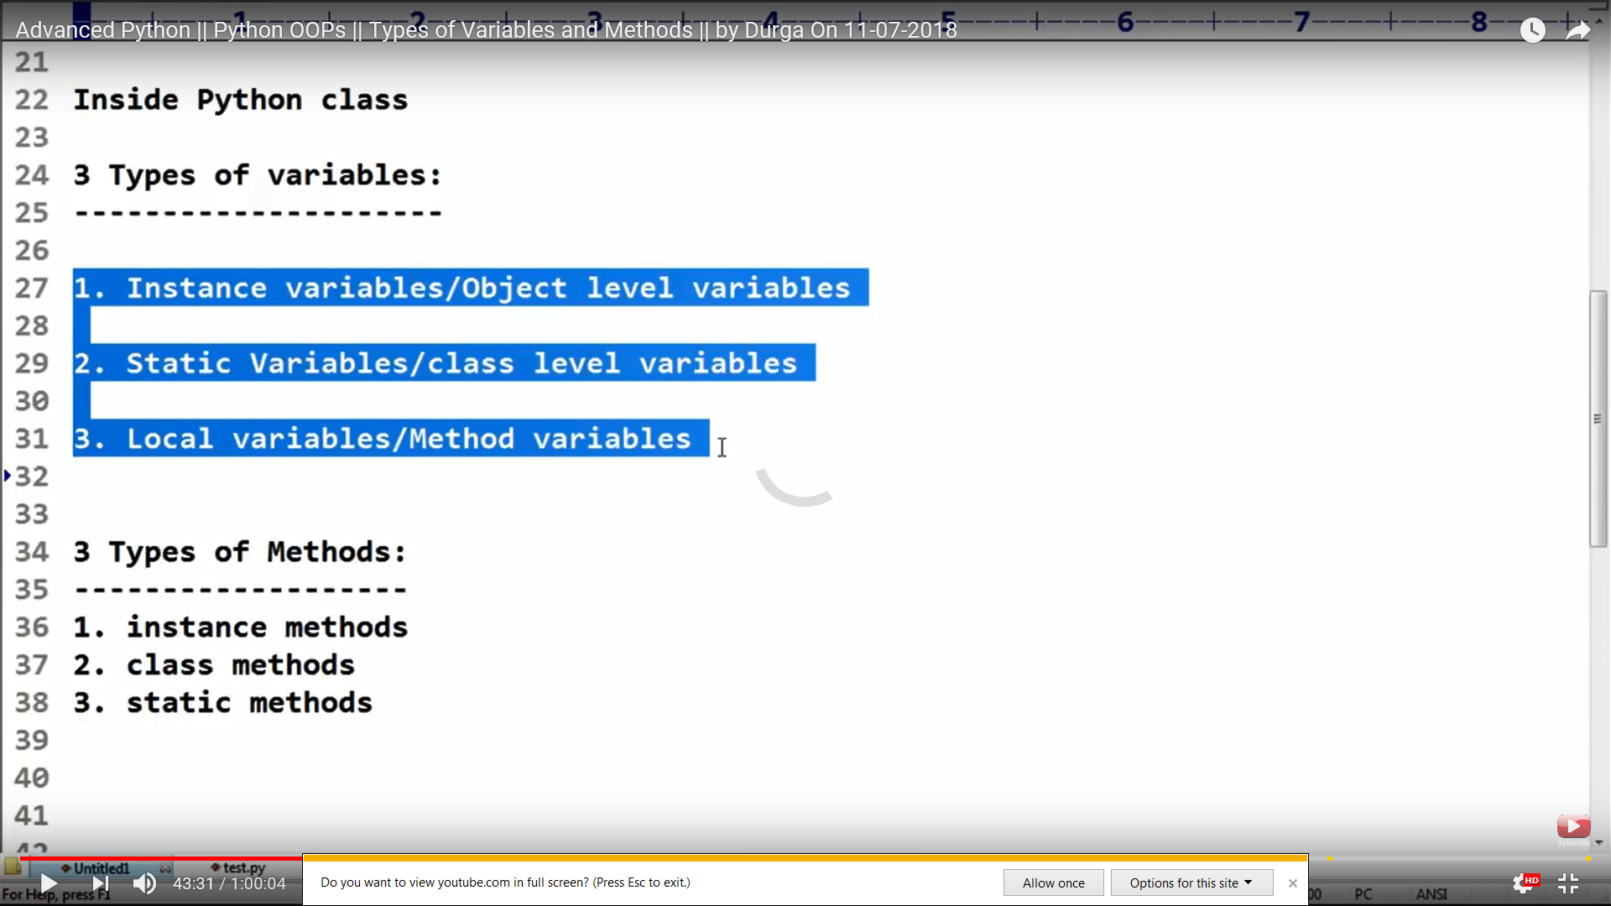

Difference between instance and staic method :

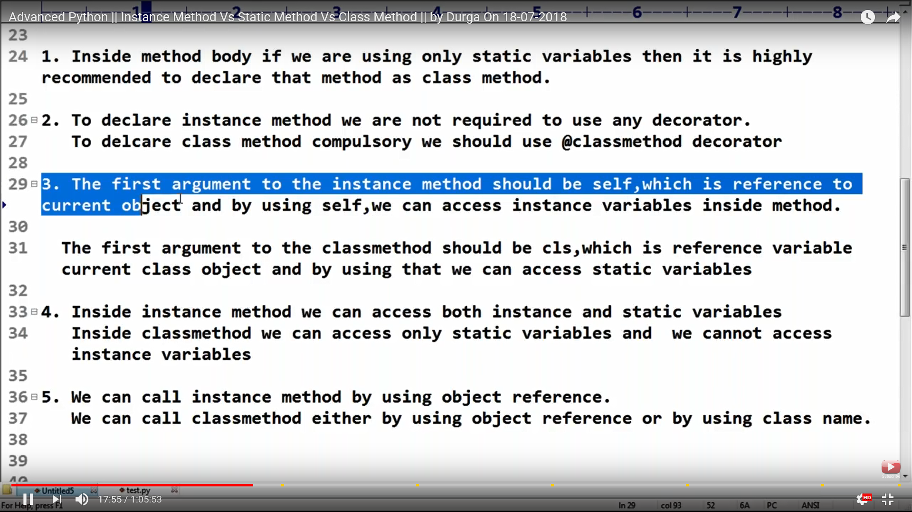

while True:

try :

WebDriverWait(driver, 10).until(EC.element_to_be_clickable((By.XPATH, "//ul[@class='pagination']//li/a[@rel='nofollow' and contains(.,'»')]"))).click()

# do your tasks on this particular page

except :

print("No more pages left")

break

driver.quit()

